JOB DESCRIPTION

Job Title | Health and safety advisor
Department | People & Workplace
Location | Leatherhead, Surrey
Reports to | Head of HR
JOB PURPOSE

The organisation has a legal requirement to appoint a competent person to fulfil the role of health and safety so that the day-to-day management of health, and safety arrangements are met and properly applied.
There is an element of working unsociable hours as the Advisor may be required to attend the site and any one of its activity locations to assist in dealing with and investigating serious injury accidents.
This is an outline Job description and may be subject to change, according to the needs of the service, in consultation with the post holder. This job description details only the main duties & responsibilities of the post, it is not intended as an exhaustive list, the duties will be discussed at your performance management review, and you are required to consider its content as part of any self-review process prior to a performance management interview.

This job description forms part of your Terms and Conditions of Employment and should be kept with a copy of your contract.

ROLE RESPONSIBILITIES

The role of the Health and Safety Advisor is important in ensuring that the QEF meets the regulatory requirements from the HSE and CQC regulatory bodies. QEF aims to work on a ‘team approach’ but there are specific roles and responsibilities attached to this post.

The Health and Safety Advisor shall have due regard to the following best practice requirements

- having regard to and observing all matters relating to the QEF policies and procedures.

- undertaking such duties as may be deemed appropriate by your Line Manager

- be part of the organisation’s supervision and annual performance review programme

- Maintain clear regular (weekly) communication with relevant colleagues

- Providing the role of 'Responsible Person' in respect of the organisation' legal compliance with regards to the Health and Safety at Work Act 1974

- Work with the Head of HR and where required seeking guidance and support from QEF’s Health and Safety Consultant in the formation, delivery and monitoring of annual aims and objectives.

- Maintaining, reviewing, and communicating all aspects of the charity's safety management system - this includes oversight of risk assessments and safe working procedures.

- Conducting workplace and work activity safety inspections as per safety plan schedules

- Developing effective relationships with stakeholders, workplace managers and supervisors to ensure that the safety components of their work activities and responsibilities are met

- Organising and hosting the organisation's Health and Safety group meeting four time a year.

- Compiling statistical information and data for the Health and Safety group and the Care Quality Committee.

- Carry out H&S tasks as recommended by the H&S Consultant and liaise as appropriate on all H&S matters.

- Conducting regular meetings with key stakeholders to determine the scope and effectiveness of the safety management system

- Planning workplace safety inspections with and without members of the Health and Safety group

- Conducting generic, specific and dynamic risk assessments (health and safety, food safety and fire safety, etc.) as and when the needs of the organisations require them

- Conducting spot-check contractor safety inspections

- Developing safe working procedures with the practitioners of identified high risk activities

- Managing and authorising the organisation's authorisation to work and ensuring that contractor's permit to work process are sound, robust and properly applied

- Conducting injury / damage incident investigations

- Lead local management investigations into serious incidents

- Assist location managers in their investigations into accidents and near miss incidents

- Provide advice and assistance in projects for renovation, construction and/or refurbishments

- Assist the Facilities Manager in determining the additional work / risk controls required to effectively apply the annual planned preventative maintenance schedule

- Conduct internal audits

- Assist the Human Resources department in determining appropriate training plans
- Develop effective networks with external agencies and individuals to ensure that the organisation's site safety arrangements remain effective

- Any other reasonable request within the remit of safety management

BEING PART OF QEF MEANS

- Actively participating in learning, development and feedback opportunities and cycles as required by QEF’s policies and procedures.
- Acting in accordance with relevant legislative and regulatory requirements as may apply from time to time.
- Supporting and encouraging the involvement of volunteers.
- Promoting QEF’s Equal Opportunities policy and avoiding any behaviour that either directly or indirectly discriminates against others on the grounds of any protected characteristic.
- Taking Health and Safety duties seriously to ensure your safety and that of your colleagues and our residents and clients.
- Being an active team player and attending team meetings and briefings to which you are invited.
- Being an ambassador of QEF’s Values and Behaviours in your approach to your role and to our staff, clients, and residents.

VALUES AND BEHAVIOURS

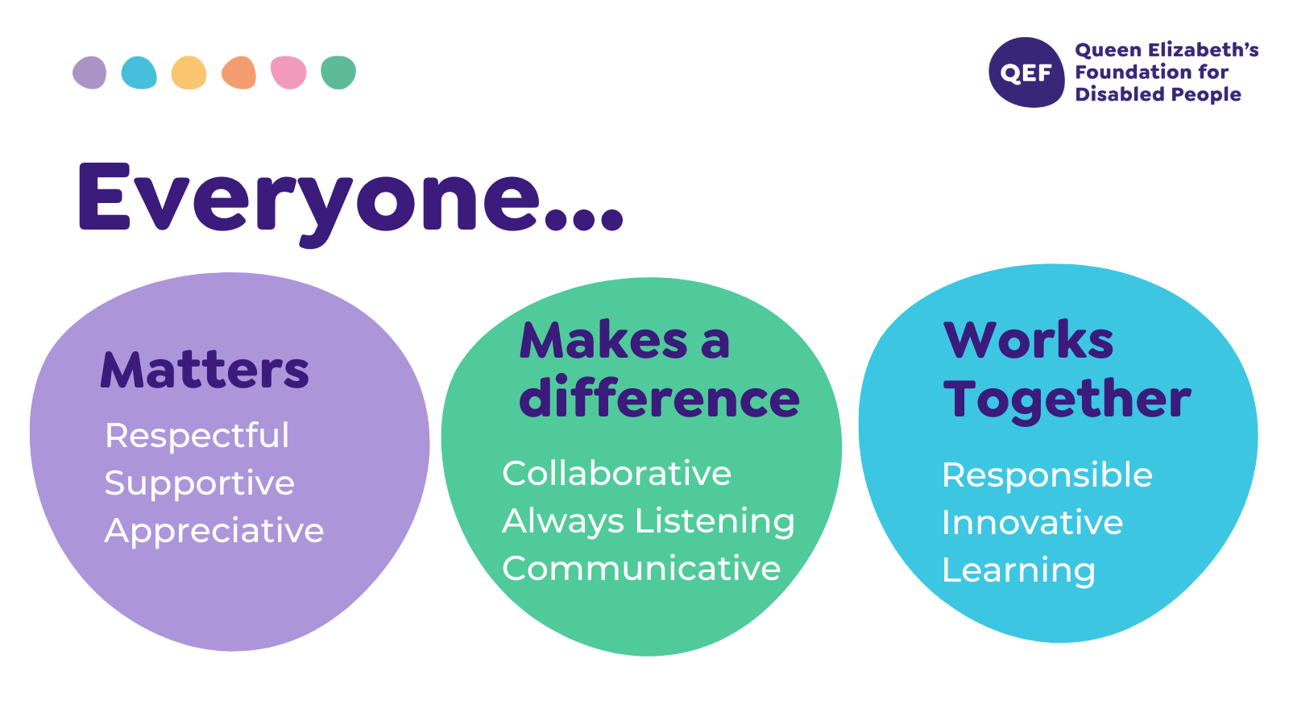
OTHER DUTIES

- You are expected to perform various tasks as necessitated by your changing role within QEF and the charity’s overall business objectives as reasonably requested by your designated manager or the CEO.
- You must read and ensure you understand the current versions of QEF’s policies and procedures and undertake to act in accordance with them at all times.
- You may be required to work at other locations in accordance with the responsibilities and duties of your role.
- The above is not an exhaustive list of duties and may be subject to change.

PERSON SPECIFICATION

Job title: | Health and safety Advisor
QUALIFICATIONS AND TRAINING |  | ESSENTIAL | DESIRABLE
Qualified to the NEBOSH National General Certificate  Working towards attaining the NEBOSH National Diploma in Occupational Health and Safety |  | Y  Y
KNOWLEDGE AND SKILLS
Good report writing skills |  | Y
Able to analyse statistical data to derive trends and causational factors |  | Y
Effective oral communications skills at all levels of the organisational |  | Y
Good, proven ability to manage their own time |  | Y
Proven ability to make decisions and solve problems and confirm actions along reporting lines |  | Y
Able to communicate and influence others to conduct specific actions in support of the safety management system and its arrangements |  | Y
EXPERIENCE
Knowledge of organisation’s management processes and able to refer items following evidence gathering and initial investigation where required |  | Y
Proven ability in devising, developing, and achieving work plans |  | Y
Evidence of carrying out H&S operations such as audits and risk assessments. |  | Y
PERSONAL ATTRIBUTES
Able to communicate and influence others to conduct specific actions in support of the safety management system and its arrangements |  | Y
Understanding of, and a total commitment to, the principles of Equality & Diversity |  | Y
Needs to hold a current driving licence and be able to drive to our different sites across the Southeast predominantly within South London, Surrey and Kent. |  | Y
Evidence of an understanding of, and a commitment to, equality and diversity principles in your practice. |  | Y
Good, proven ability to display a professional attitude and behaviour commensurate with the responsibility that the role requires |  | Y
Demonstrates leadership through leading by example and acting as 'Chair' during project meetings as directed |  | Y
Demonstrable ability to be an ambassador of QEF’s Values & Behaviours. |  | Y

