JOB DESCRIPTION

Job Title: | Occupational Therapist (Band 5)
Department: | Occupational Therapy
Location: | Care and Rehabilitation Centre, Woodlands Road, Leatherhead, KT22 0BN
Reports to: | Occupational Therapy Lead

QEF & ITS FAMILY OF CHARITIES

QEF is a Surrey based charity committed to providing life-transforming services that enable people with disabilities to increase their independence and achieve their goals in life.

We work with over 5,000 disabled children and adults every year with physical or learning disabilities or acquired brain injuries. Whether it’s gaining new skills to live independently, rehabilitation after a brain injury or stroke, or improving independence through increased mobility and accessible holidays; QEF helps disabled people to fulfil their potential in life.

ROLE CONTEXT

At QEF Care and Rehabilitation Centre (CRC) we offer neurorehabilitation to clients after a stroke or other acquired brain injury. Our specialist multi-disciplinary team provides residential or outpatient therapies to those with physical, cognitive and/or communication disabilities, which may also include mild to moderate behavioral problems.

We have a diverse range of one-to-one support programs, tailored to help improve social and functional abilities as well as support for that important move home.

Growing demand for our services, combined with our passion for delivering the highest standards of care and treatment, inspired the move to our new, state-of-the-art Care and Rehabilitation Centre in July 2020. The Centre, especially designed for us, provides a fantastic hub of expertise and technology for people with a wide range of disabilities. It is located next to our head office, Leatherhead Court, in Leatherhead, Surrey.

JOB PURPOSE

To be responsible for the occupational therapy assessment and treatment of clients with acquired brain injury, stroke and other neurological conditions whilst under the direction and supervision of the senior Occupational therapists.

To work as a member of the wider multi-disciplinary team ensuring continuity and consistency regarding clients’ physical and cognitive management.

ROLE RESPONSIBILITIES

- To manage and prioritise own neurological clinical caseload with guidance and support from your clinical supervisor and wider Occupational Therapy team to organize the work efficiently regarding clinical priorities and use of time.
- To work with clients in both individual and group settings addressing their goals, using functional and impairment-based treatment methods.
- To plan and carry out individual Occupational Therapy treatment programmes which reflect the client’s goals in both the Rehab Centre and where appropriate in the community. This will be completed with the required support from your clinical supervisor and wider OT colleagues.
- To evaluate treatment and use reflective practice within supervision to improve client care and modify as required.
- To develop a good knowledge and application of risk assessment including carrying out intervention within the community and the use of wheelchair accessible vehicles.
- To carry out access and home visits with senior clinical support as appropriate, including liaising with social services, care agencies and relatives.
- To liaise with external agencies to assess for and arrange provision of appropriate equipment and adaptations to maximise independence. This may include private case managers.
- To attend and contribute to client case reviews and multi-disciplinary meetings.
- To develop skills in communicating with clients with a range of physical, cognitive, and communication difficulties.
- Ensure that feedback and appropriate information is given to clients in a client centred manner.
- To provide feedback and advice to care staff and other members of the multi-disciplinary team regarding the assessment and treatment of a client’s physical, functional, cognitive, sensory and perceptual abilities. This includes psychosocial needs. Feedback may be offered to relatives, carers and external agencies e.g. occupational health and university support staff, as consented by the client or their advocate(s).
- Make referrals to other agencies as required/appropriate.
- To be trained in key worker responsibilities for clients including organising regular goal setting meetings and liaising with the clients and family as consented by the client.
- To attend and if appropriate, participate with in-service training programmes including feedback on courses attended.
- To review and reflect on your own practice and performance through effective use of professional supervision and appraisal.

BEING PART OF QEF MEANS

- Actively participating in learning, development and feedback opportunities and cycles as required by QEF’s policies and procedures.
- Acting in accordance with relevant legislative and regulatory requirements as may apply from time to time.
- Supporting and encouraging the involvement of volunteers.
- Promoting QEF’s Equal Opportunities policy and avoiding any behaviour that either directly or indirectly discriminates against others on the grounds of any protected characteristic.
- Taking Health and Safety duties seriously to ensure your safety and that of your colleagues and our residents and clients.
- Being an active team player and attending team meetings and briefings to which you are invited.
- QEF is committed to safeguarding and promoting the welfare of children and adults at risk and expects all staff and volunteers to share this commitment. All staff and volunteers must be responsible and accountable for their safeguarding practice and proactive in identifying and reporting safeguarding concerns.
- Being an ambassador of QEF’s Values and Behaviours in your approach to your role and to our staff, clients, and residents.

VALUES AND BEHAVIOURS
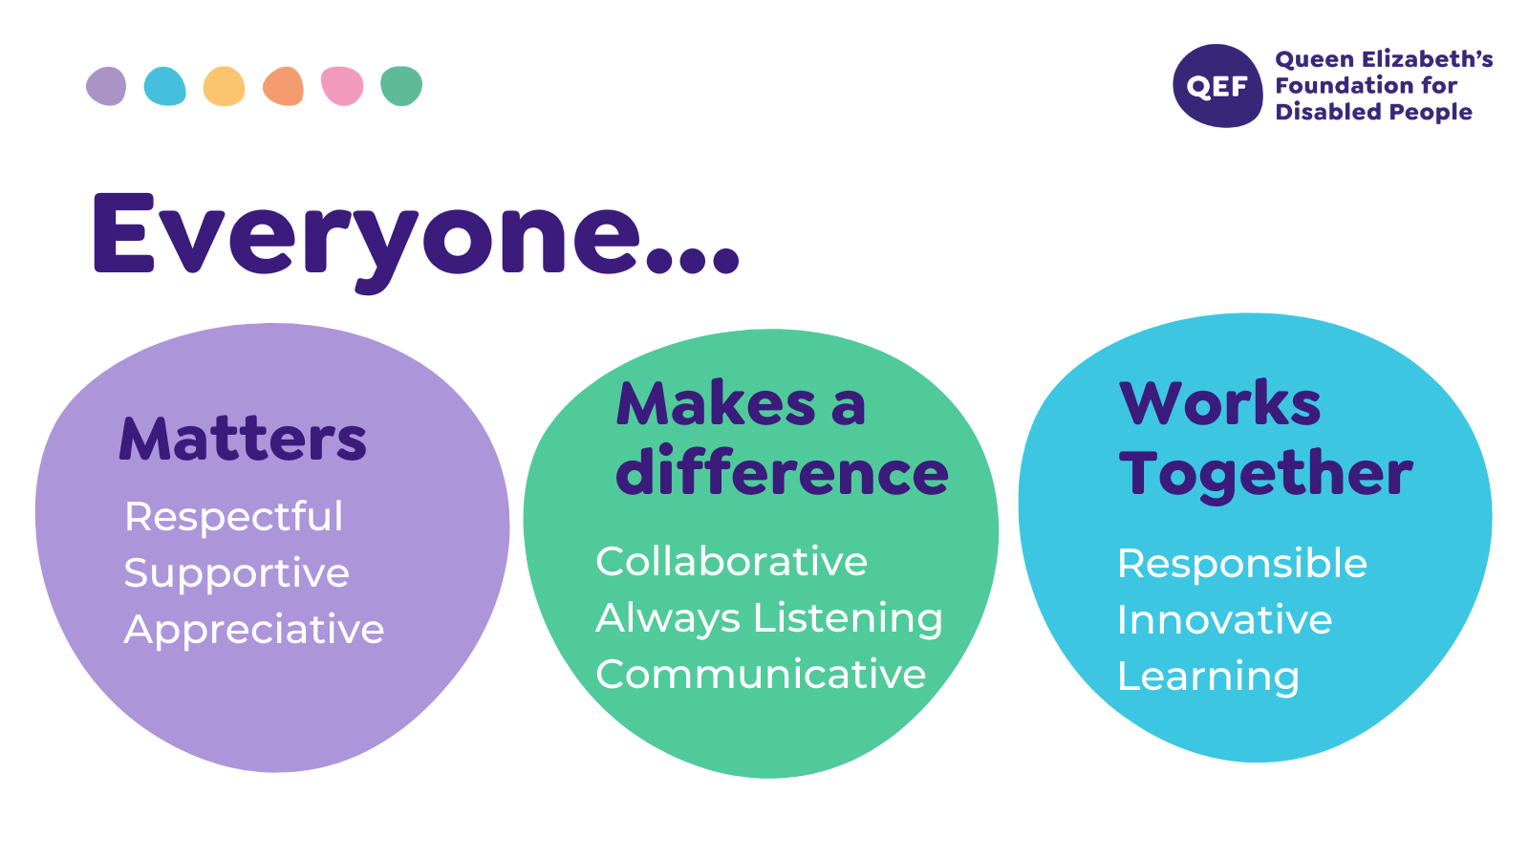
OTHER DUTIES

- You are expected to perform various tasks as necessitated by your changing role within QEF and the charity’s overall business objectives as reasonably requested by your designated manager or the CEO.
- You must read and ensure you understand the current versions of QEF’s policies and procedures and undertake to act in accordance with them at all times.
- You may be required to work at other locations in accordance with the responsibilities and duties of your role.
- The above is not an exhaustive list of duties and may be subject to change.

PERSON SPECIFICATION

Job title: | Therapist Band 5
Service: | Care and Rehabilitation Centre
QUALIFICATIONS AND TRAINING |  | ESSENTIAL | DESIREABLE
Diploma or Degree in Occupational Therapy. |  | Y
Membership of Health Professionals council. |  | Y
Membership of BAOT. |  |  | Y
Membership of neurological specialist section (SSNP). |  |  | Y
Evidence of relevant post graduate courses/ continual professional development |  |  | Y
KNOWLEDGE AND SKILLS
Excellent written and verbal communication skills including use of Microsoft word, PowerPoint, excel and outlook. |  | Y
Knowledge and skills of upper limb splinting. |  |  | Y
Knowledge of national clinical guidelines in relation to stroke and head injury. |  | Y
Knowledge and skills in using a range of outcome measures. |  |  | Y
Knowledge and skills in using different treatment techniques including Bobath. |  |  | Y
Can use own initiative to prioritise caseload and use clinical reasoning to make sound decisions and problem solve. |  | Y
Knowledge and skills in a range of assessments and treatment techniques including sensory re-education, desensitization, neglect. |  |  | Y
EXPERIENCE
Experience of working in neurology, either as a student placement or post graduate. |  |  | Y
Experience of working in a multidisciplinary team. |  |  | Y
Basic manual handling training. |  | Y
Experience in working with complex physical conditions. |  |  | Y
PERSONAL ATTRIBUTES
Ability to demonstrate efficient and effective self-management including use of time, organisation, planning and problem solving. |  | Y
Ability to use own initiative but ask for assistance where appropriate. |  | Y
Able to use self-reflection to improve clinical skills. |  | Y
To respond effectively to constructive feedback. |  | Y
Commitment to continuous professional development. |  | Y
To be empathetic and passionate in working with clients with complex physical, cognitive and psychosocial needs and their families. |  | Y
Ability to work flexibly and proactively to meet the needs of a varied clinical caseload. |  |  | Y
Ambassador of QEF’s Values and Behaviours. |  | Y

