JOB DESCRIPTION

Job Title: | Lead Clinical Psychologist/Neuropsychologist
Department: | Therapies
Location: | Care and Rehabilitation Services
Reports to: | Head of Clinical Services

QEF & ITS FAMILY OF CHARITIES
QEF is a Surrey based charity committed to providing life-transforming services that enable people with disabilities to increase their independence and achieve their goals in life.

We work with over 5,000 disabled children and adults every year with physical or learning disabilities or acquired brain injuries. Whether it’s gaining new skills to live independently, rehabilitation after a brain injury or stroke, or improving independence through increased mobility and accessible holidays; QEF helps disabled people to fulfil their potential in life.

QEF is structured into three main services - Independent Living Services, Mobility Services and Neuro Rehabilitation Services. These are augmented by QEF Retail Trading and a family of smaller charities - MERU which provides innovative product solutions; Sutton Shopmobility and VASD which offer access to and loans of mobility equipment.

ROLE CONTEXT

QEF Neuro Rehabilitation Service offers neurorehabilitation and transitional support to clients after a stroke or other acquired brain injury. Our specialist multi-disciplinary team provides residential or outpatient therapies to those with physical, cognitive and/or communication disabilities, which may also include mild to moderate behavioural problems.
We have a diverse range of one-to-one support programmes, tailored to help improve social and functional abilities as well as support for that important move home and back to education or work.
The role will work with a range of in-patients and out-patients alongside the existing teams.

JOB PURPOSE
To lead the psychology team and provide a direct psychological service to clients, carrying out assessments of their needs and abilities and using this information to formulate and monitor appropriate programmes and strategies. To support staff engaged in the cognitive, physical communication, functional, social and emotional rehabilitation of adults with a range of neurological conditions

ROLE RESPONSIBILITIES
- To lead and support the psychology team at CRC
- To provide a direct psychological service to clients and their families at Neuro Rehabilitation Services, conducting and interpreting a wide range of assessment procedures.
- To develop the out-patient service for non-residential clients requiring clinical psychology.
- To provide therapeutic support to clients through group work and individual sessions.
- To prepare detailed professional reports on client assessment and progress and make recommendations for future provision.
- To direct and supervise the clinical work of the clinical staff and students within the centre as appropriate.
- To provide training and consultation to colleagues on the cognitive, emotional, social and behavioural implications of acquired brain injury and to devise, implement and monitor strategies to facilitate learning and management of the behaviour of clients.
- To initiate and engage in formal research projects, publishing as appropriate.
- To conduct analysis of outcomes and participate in service evaluation.
- To support the CRC General Manager, Head of Clinical Services,. the Psychology team and members of the multi-disciplinary team, as required.
- To advise the CRC General Manager and Head of Clinical Services on the suitability of prospective clients.
- To represent the Service at meetings, conferences etc. networking and giving presentations as required.
- To keep abreast of developments in the field of brain injury rehabilitation.
- To provide supervision to less experienced colleagues in Clinical Psychology.
BEING PART OF QEF MEANS
- Actively participating in learning, development and feedback opportunities and cycles as required by QEF’s policies and procedures.
- Acting in accordance with relevant legislative and regulatory requirements as may apply from time to time.
- Supporting and encouraging the involvement of volunteers.
- Promoting QEF’s Equal Opportunities policy and avoiding any behaviour that either directly or indirectly discriminates against others on the grounds of any protected characteristic.
- Taking Health and Safety duties seriously to ensure your safety and that of your colleagues and our residents and clients.
- Being an active team player and attending team meetings and briefings to which you are invited.
- QEF is committed to safeguarding and promoting the welfare of children and adults at risk and expects all staff and volunteers to share this commitment. All staff and volunteers must be responsible and accountable for their safeguarding practice and proactive in identifying and reporting safeguarding concerns.
- Being an ambassador of QEF’s Values and Behaviours in your approach to your role and to our staff, clients, and residents.

VALUES AND BEHAVIOURS

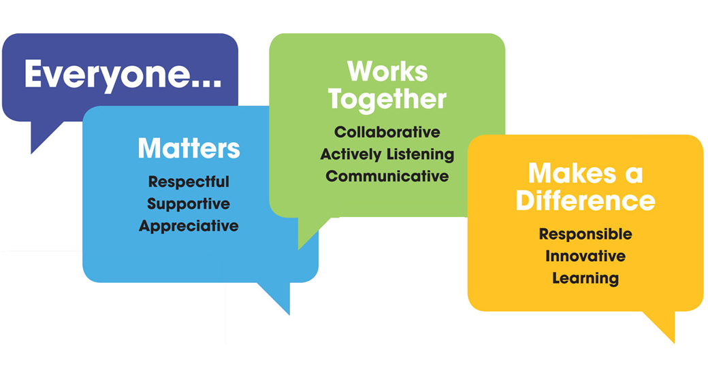

OTHER DUTIES
- You are expected to perform various tasks as necessitated by your changing role within QEF and the charity’s overall business objectives as reasonably requested by your designated manager or the CEO.
- You must read and ensure you understand the current versions of QEF’s policies and procedures and undertake to act in accordance with them at all times.
- You may be required to work at other locations in accordance with the responsibilities and duties of your role.
- The above is not an exhaustive list of duties and may be subject to change.

PERSON SPECIFICATION

Job title: | Psychology Lead
Department: | Therapies
QUALIFICATIONS AND TRAINING |  | ESSENTIAL | DESIREABLE
Doctorate level training in clinical psychology/ neuro-psychology |  | Y
Current HCPC registration. |  | Y
Professional qualifications and experience in any of the following: Neuropsychology, counselling, psychotherapy, or behaviour management. |  |  | Y
Further training/ Qualification relevant to Neuro-rehabilitation. |  |  | Y
KNOWLEDGE AND SKILLS
Able to manage workload independently and work as part of a multi-disciplinary team. |  | Y
Excellent written and verbal communication skills. |  | Y
Competent in Microsoft Word, Excel and Outlook. |  | Y
Good decision making and problem solving skills. |  | Y
Excellent clinical skills |  | Y
High level knowledge of the theory and practice of at least two specialised psychological therapies. |  | Y
Ability to manage a small team of Psychologists |  | Y
Networking abilities within the profession |  |  | Y
Skills in providing consultation to other professional and nonprofessional groups. |  | Y
The ability to use and interpret specialist psychological and neuro-psychological assessment materials. |  | Y
Quality assurance |  | Y
Knowledge of current theoretical models and skills in working with people whose behaviour challenges. |  | Y
Evidence of continuing professional development as recommended by the BPS. |  | Y
Doctoral level knowledge of research methodology, research design and complex, multivariate data analysis as practised within the clinical fields of psychology. |  | Y
Ability to contain, explore and formulate an understanding of high levels of distress both directly with patients and indirectly consultation with other staff. |  | Y
Knowledge of the theory and practice of specialised psychological therapies with individuals with acquired brain injury. |  |  | Y
Knowledge of legislation in relation to the client group. |  |  | Y
Able to reflect on how one’s own issues of difference and diversity influence decision making in clinical practice. |  |  | Y
Service development. |  |  | Y
EXPERIENCE
Experience with Adult Neurologically impaired adults. |  | Y
Experience of management at least at team/middle management level. |  | Y
Working with carers. |  | Y
Experience working with people with cognitive impairments. |  | Y
Experienced in the use of neuropsychological assessment to inform care planning. |  | Y
Experience working with clients whose behaviour challenges. |  | Y
Experience delivering supervision. |  | Y
Experience working with people who have an acquired brain injury / in a neuro-rehab setting. |  | Y
Experience delivering mindfulness based interventions. |  |  | Y
Experience facilitating psycho-education or psychological therapy groups. |  |  | Y
Experience working with families. |  |  | Y
Experience working with staff teams in a residential setting. |  |  | Y
PERSONAL ATTRIBUTES
Assertiveness/adaptability |  | Y
Ability to manage and deal with change |  | Y
Ability to use own initiative |  | Y
Willingness and ability to work within the ethos of the Service |  | Y
Good time management |  | Y
Ability to manage self and emotions especially in stressful situations |  | Y
OTHER
Ability to teach and train others, using a variety of complex multi-media materials suitable for presentations within public, professional and academic settings. |  | Y
Experience of working within a multicultural framework. |  | Y
Ability to identify and employ mechanisms of clinical governance as appropriate, to support and maintain clinical practice in the face of regular exposure to highly emotive material and challenging behaviour. |  | Y
Ability to work effectively within a multidisciplinary service setting. |  | Y
Able to be flexible with working schedules, for instance working occasional evening or early mornings to accommodate families and to support staff working shift patterns. |  |  | Y

